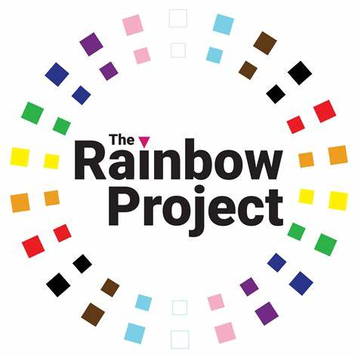
Justice Committee Briefing: Hate Crime Provisions in the Criminal Justice (Sentencing, etc.) Bill

About The Rainbow Project
Since 1994, the Rainbow Project has been working for a better Northern Ireland for LGBTQIA+ people and their families. We change lives through our service provision which mitigates the impact of discrimination, and we change society through our training, campaigning and policy work, which seeks to eliminate the root causes of that discrimination and deliver full social and legal equality for LGBTQIA+ people.
We currently employ a team of 36 staff located across our three offices in Belfast & Foyle, and we deliver services and programmes across Northern Ireland. One of these services is our Hate Crime Advocacy Service (HCAS), which sits as part of the wider HCAS team managed by Victim Support and funded through the Department of Justice and the PSNI.
This Hate Crime Advocacy Officer provides support through several routes: outreach and support for LGBTQIA+ people who have reported a hate crime to the PSNI and who are referred to us through the HCAS system, as well as support for those who have not yet reported or do not plan on reporting hate crimes to the PSNI for a variety of reasons. We work closely alongside our HCAS partners Victim Support, Disability Action and the Migrant Centre to support victims of hate crime across multiple characteristics, in recognition of the different needs and intersecting identities of individuals within the LGBTQIA+ community.

Background and Overview
This briefing will focus specifically on the hate crime (‘Aggravation by hostility’) provisions within the Criminal Justice (Sentencing etc.) Bill (herein the ‘Sentencing Bill’), with a particular focus on the potential impact of these changes on anti-LGBT hate crime.
Six years since the publication of the Marrinan Review into Hate Crime Legislation in Northern Ireland, we welcome the publication of this Bill and the inclusion of a new approach to dealing with hate crime in Northern Ireland. In our contributions to this Review, we recommended the move from the current ‘aggravated sentencing’ model to the ‘aggravated offences’/statutory aggravator model adopted in Part 6 of the Sentencing Bill, and we welcome this change.
We are concerned, however, that a number of key recommendations within this Review will not be met through this legislation: namely, the inclusion of both ‘transgender identity’ and ‘variations in sex characteristics’ within the protected characteristics covered by this new aggravated offences model. This is particularly disappointing considering that, in its response to the Marrinan Review and noting that the PSNI already record hate incidents and hate crimes against transgender persons, the Department of Justice accepted the need to include ‘transgender identity’ within any new hate crime legislation.
It is worth noting also that Judge Marrinan recommended both a standalone Hate Crime Bill, rather than having hate crime provisions included within wider legislative reforms, as well as the modernisation of the ‘stirring up hatred’ offences to be fit for a more online world. While we understand the constraints of a shortened mandate, it is nevertheless disappointing that neither of these recommendations are being brought forward, and we would encourage both the Minister and the Department to establish a timetable for these measures being brought in.

Current Scale and Trends
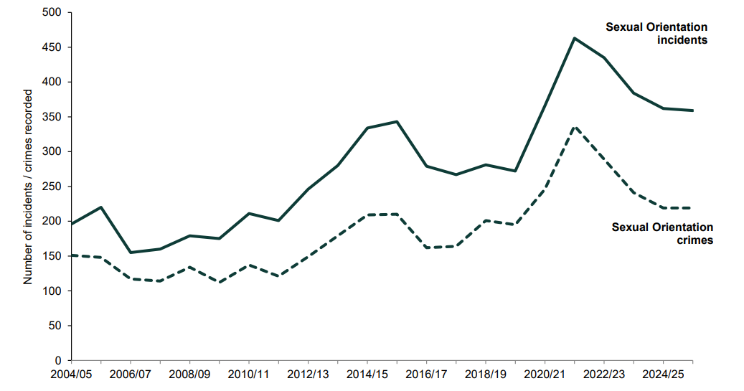
Fig. 1. Trends in sexual orientation incidents and crimes recorded by the police since 2004/05
In 2025/26, 359 sexual orientation hate incidents were recorded by the PSNI, a slight decrease from 362 in 2024/25. 219 sexual orientation hate crimes were recorded in 2025/26, which was the same as the previous year.
The PSNI currently records transgender identity hate crimes and incidents, despite the Public Order (NI) Order not including transgender identity within its protected characteristics. In 2025/26, 57 transgender identity hate incidents were recorded, a drop from 64 incidents in 2024/25. 27 transgender identity hate crimes were recorded, dropping from 36 in 2024/25.
While recorded transphobic crime appears low, there is strong anecdotal evidence to suggest that this is could be due to underreporting rather than lower prevalence. We’ve seen a particular downturn in reporting from the peak in both homophobic and transphobic hate incidents and crime in 2020/21 – this could be a result of many different factors, including COVID-19 lockdowns, and/or a reduction in confidence following the PSNI’s withdrawal from participation in Belfast Pride.
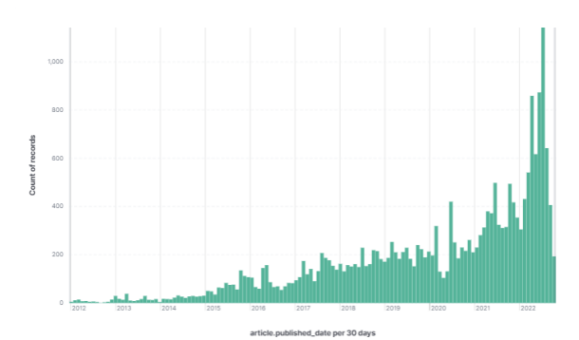
Fig 2. Frequency of trans-related articles by month, UK press, 2012 - 2019
This reduction in recorded and reported crimes and incidents, particularly for transgender identity, runs contrary to the significantly increasing social, political and media discourse surrounding transgender people, the vast majority of which has skewed negative over the past decade.
Research published by Amnesty International found that, between January 2020 and April 2025, media coverage of issues about trans people has been excessively high compared to the size of the trans population, their role in society, and public interest in these topics.
Across the four outlets included within the analysis (The Guardian, The Times, The Telegraph and The Sun) a total of 17,000 articles were published between January 2020 and April 2025, an average of 264 articles per month, or 9 per day. Most media reports about trans people have a negative sentiment, while trans people are hardly seen in stories. When they do appear, it is as criminals or murder victims. This increased attention, most of it negative in tone, has an impact on levels of discrimination, unconscious bias and direct violence that trans people experience in everyday life.
During the period of the COVID-19 pandemic, as part of our ongoing engagement with LGTBQIA+ communities and stakeholders, we held a public survey in Northern Ireland over three months in 2021. Over 1100 responses were received from our State of the Community survey which contained over 130 different questions. These questions covered a range of experiences in daily life, education, healthcare, experiences of crime (domestic abuse, hate crime) and experiences of homelessness.
Over 800 respondents engaged with the section on Hate Crime, key findings were that:
- Over 43% were worried or very worried about being a victim of crime.
- Over 42% of those who experienced hate crime felt that the incident was motivated by the perpetrator(s) knowing or believing they were lesbian/gay/bisexual or transgender.
- Over 51% did not report to the PSNI, Key reasons for not reporting included they didn’t believe that it would be taken seriously, didn’t believe that the PSNI could do anything about it, that it was not serious enough and they were fearful of repercussions.
- 16% reported incidents directly to the Rainbow Project
The majority of respondents told us that they have taken steps to prevent themselves from being a victim of crime:
- 60% avoid certain areas at certain times
- 43% alter their behavior
- 36% advised that they avoid leaving the house after dark and others have installed additional security measures, learned self-defence or carry a device.
We are currently rerunning this survey, and plan to publish updated findings later this year. Preliminary findings can be shared in confidence with the Committee on request.

Specific Bill Provisions: Part 6 – Particular persons or groups: Aggravation by hostility

Clause 33
As outlined above, we do not believe that the protected groups currently set out in ‘Clause 33 – Aggravation by hostility’ are sufficient to provide full protection for all marginalised groups in Northern Ireland. In particular, the exclusion of ‘transgender identity’ flies in the face of both commitments that have been made by the Department of Justice and of the evidence that exists. The Minister for Justice, during the second reading debate on the Bill, said:
Of course, the need for provisions was well documented in the findings of Judge Marrinan's public consultation and the 10 years' worth of evidence that the PSNI shared, showing that transgender people are victims of hate crime and, sadly, increasingly so. This is the only part of these islands where there are no specific protections for transgender people. I do not think that that is a uniqueness that any of us wishes to continue. I sought the agreement of colleagues to add transgender to the list of protected groups, and, on the basis of what, I thought, was consensus, I did so. Unfortunately, that was not the case, and I had to remove it from the Bill.
Since the PSNI began recording crimes and incidents motivated by hostility towards an individual based on their transgender identity in 2009/2010, rates of these crimes and incidents has steadily risen. From a base of 4 crimes and 14 incidents in 2009/10, figures for crimes and incidents with a transgender identity motivation now steadily hover around 30-40 crimes and 70 incidents per year over the past six years.
There is a clear rationale and consistent evidence base for the inclusion of transgender identity within these protected characteristics. We would recommend that the committee makes the following amendment:
“After ‘33(1)(d) hostility related to disability’, insert:
(e) hostility related to transgender identity”
“After ‘33(2)(a)(iv) a disability group;’ remove ‘or’ and insert:
(v) a transgender identity group”
“At end of ‘33(4)’ insert:
“transgender identity” means a person who is undergoing, proposing to undergo or having undergone a process or part of a process of gender reassignment, including transsexual and non-binary persons”
We also support the recommendation of the Women’s Policy Group, of which The Rainbow Project is a member, for the inclusion of a statutory aggravator for misogyny. While we recognise that there a range of views on the best approach for introducing a statutory aggravator for misogyny – for instance, the Scottish approach of bringing a standalone Misogyny Bill – given the constraints of the legislature in Northern Ireland we believe that it is vital to seize the current opportunity to introduce misogyny within this current Bill.
We understand that the Women’s Policy Group has briefed the Committee on the proposed text of such an amendment, and we support this being introduced alongside the addition of ‘transgender identity’ to the list in Clause 33.
Further, we believe it is important for the Committee and the Department to give further consideration to the inclusion of both ‘hostility related to variations in sex characteristics’ and ‘hostility related to gender expression’. The Hate Crime and Public Order (Scotland) Bill included the former to ensure intersex individuals – people who’s physical sex is neither definitively male or female – were covered where hate crimes or incidents were motivated by hostility against them for that reason. Whether or not variations in sex characteristics will be incorporated within the Bill, it is important to ensure that the PSNI is equipped to recognise, record and respond to crimes and incidents with this motivation.
Over the past year we have also witnessed a spate of assaults and harassment targeting specifically drag artists, performers, and individuals with diverse gender expressions but who would not necessarily identify as transgender. While those individuals may be protected due to being perceived to having either/both of the ‘sexual orientation’ or ‘transgender identity’ characteristics, having clear and disaggregated data and avenues for prosecution would improve community confidence in policing, reporting and prosecution.
For these reasons we would encourage both the Committee and the Department to give further consideration to the inclusion of these two characteristics, particularly in the context of the Clause 35 powers to introduce additional protected characteristics.

Clause 34
Broadly, we are supportive of the measures included within Clause 34 of the Bill, and particularly the recognition that ‘one or more of the kinds of hostility’ referenced in Clause 33 can be stated and recorded on conviction. This will be key where, for example, an individual is attacked or harassed because of both their race and their sexuality (i.e. a black gay person), or their disability and transgender identity, among others. To ensure this is clear, we would recommend a change to Clause 33(2) to state:
“An offence committed by A is aggravated by hostility of one or more of the kinds mentioned in subsection (1) if—"
For the purposes of adequate rehabilitation and reducing further hatred against marginalised groups, it is vital that intersecting forms of discrimination, bias or hostility can be recognised and recorded, and addressed by the Prisons and Probation Services.

Clause 35
Again, we are broadly supportive of the powers included within Clause 35 of the Bill, with some caveats.
As referenced above, we believe there are a number of groups which are not currently included within the Bill but which should be, given the clear evidence of need, for instance transgender identity and misogyny. We further recognise that there are a number of characteristics which we believe should be added, however the Department requires further evidence and analysis before doing so. To that end, providing the Department with flexibility to add groups to these protections without bringing forward primary legislation is positive, while we would nevertheless encourage a process of parliamentary scrutiny prior to this occurring.
We are, however, concerned that, in the context of the regression of rights across the UK – particularly targeting migrants, refugees/asylum seekers, and trans people – there is a real danger that the power to remove groups could be used to remove rights and protections from a certain group for political expediency. Such recent regressions in rights - including attempts to disapply sections of the European Convention on Human Rights from being used to challenge asylum claims, and the recent ‘For Women Scotland v The Scottish Ministers’ Supreme Court judgment and accompanying updated to the EHRC’s Code of Practice – have had a chilling effect on minority groups who see hard-won rights being overturned or revoked. It’s vital that full scrutiny is afforded to efforts to remove groups or characteristics, and that these should go through rigorous parliamentary oversight.

Department of Justice (December 2020) - Hate Crime Legislation in Northern Ireland – Independent Review (para 68)
Department of Justice (July 2021) - Review of Hate Crime Legislation in Northern Ireland – Departmental Response
PSNI (May 2026) – Incidents and Crimes with a Hate Motivation Recorded by the Police in Northern Ireland
Ibid
Prof Paul Baker (November 2019) - Representing trans people in the UK press – a follow-up study
Ibid
Amnesty International (May 2026) - Like a snowball: the growth and impact of the gender critical movement in the UK
NI Assembly (March 2026) - Official Report: Monday 16 March 2026
The PSNI collected data on crimes and incidents with a transgender identity motivation from 2006/07, however, in 2009/10, improvements were made to the data quality assurance process for incidents and crimes with a transgender identity motivation to ensure the motivations are being accurately assigned. For this reason, the majority of publications and trend analysis uses figures beginning in 2009/10.
PSNI (November 2025) - Hate Motivation Annual Trends 2004/05 to 2024/25

